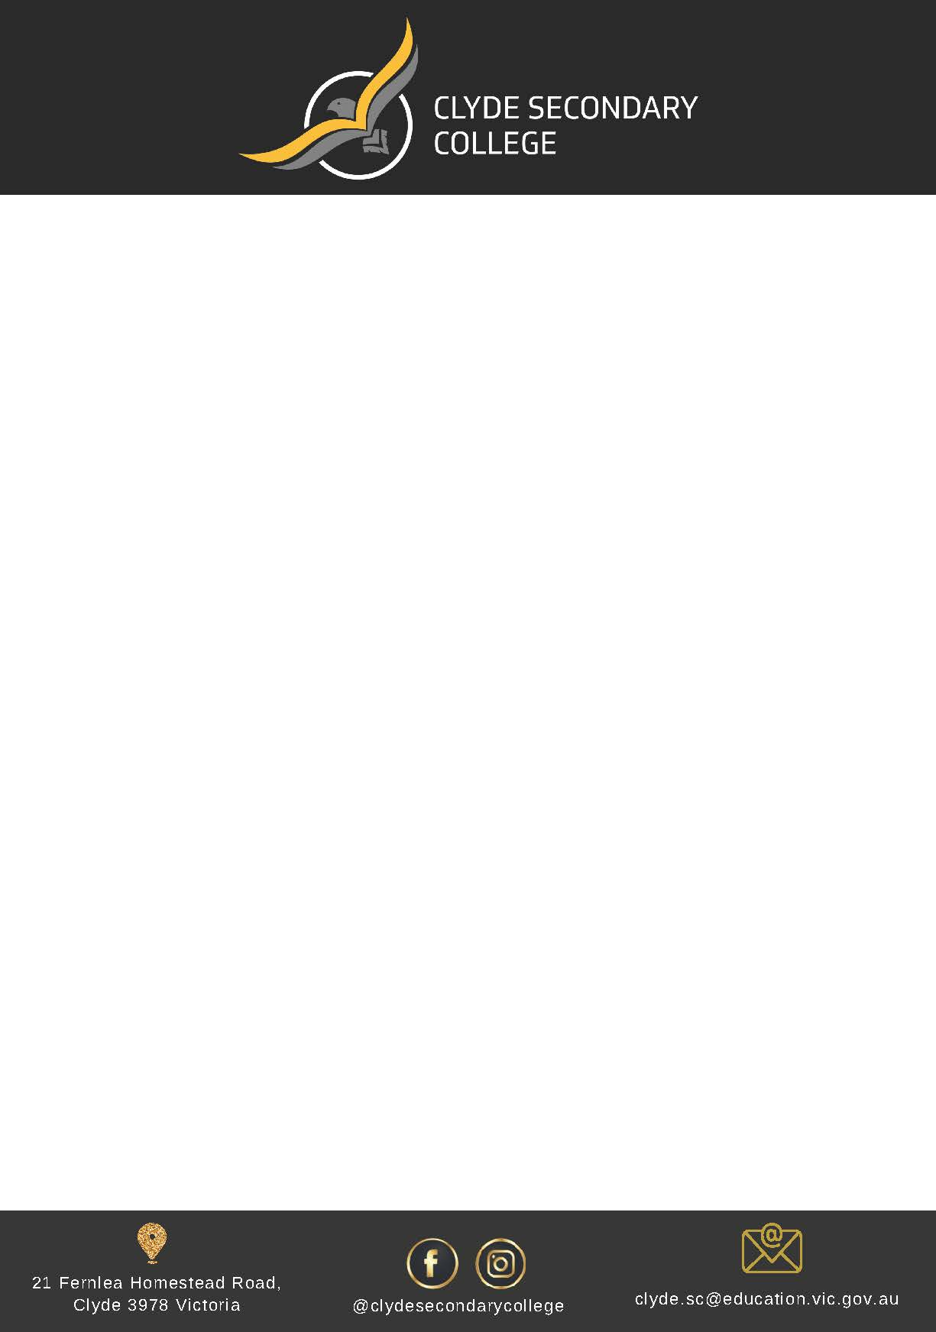

Dear Parent/carer,

Clyde Secondary College is looking forward to another great year of teaching and learning and would like to advise you of Clyde Secondary College’s voluntary financial contributions for 2024.

Schools provide students with free instruction to fulfil the standard Victorian curriculum and we want to assure you that all contributions are voluntary. Nevertheless, the ongoing support of our families ensures that our school can offer the best possible education and support for our students. We want to thank you for all your support, this will make a huge difference to our school and the programs we can offer.

Within our school this support will allow us to provide enhanced digital learning opportunities including new STEM experiences and a wider subject offering.

**Digital Devices**

We recognise that in today’s digital world all students need access to a digital device. We are committed to using ICT throughout our teaching practices to enhance and improve student outcomes. Our college supports a Bring Your Own Device program. This program ensures students have “anywhere, anytime” access to learning resources. We have attached a list of minimum requirements for device specifications that need to be met if you intend to bring your own device for classroom usage. If you do not have a suitable device and wish to purchase one, we have approached a Department of Education & Training authorised supplier to assist with the purchasing process by offering a number of laptops at different price points. We have attached details of the online purchasing portal specifically designed for school environments. Please note you are under no obligation to purchase from this supplier and may choose to purchase a device from any supplier.

For further information on the Department’s Parent Payments Policy please see a one-page overview attached.

Yours sincerely,

**Kondilo Prades Travis Cute**

**Principal School Council President**

|  |  |
| --- | --- |
| **Curriculum Contributions** - items and activities that students use, or participate in, to access the Curriculum | **Amount** |
| *Student ID Card* | $10 |
| *Classroom consumables, materials & equipment*   * *Art – paint, crayons, canvas, coloured paper ($40)* * *Design Tech –wood, food ($60)* * *Science – lab equipment and materials ($20)* * *Performing Arts – costumes, masks, scripts, instruments ($20)* * *Health and Physical Education - equipment ($20)* | $160 |
| *Online Subscriptions (in lieu of textbooks)*   * Essential Assessment ($10) * Maths Online ($20) – all students except 9 Extension Maths * Education Perfect all subjects – **if not purchased via booklist** ($65) * Edrolo (Science) **– if not purchased via booklist** ($25) * Edrolo (Maths) – 9 Extension maths only **– if not purchased via booklist** ($105) * Music Ed ($35) Yr 8&9 | $120 (Yr7)  $155 (Yr 8 & 9)  $240 (Yr 9 Extension Maths group) |
| *Printing and photocopying of worksheets and learning materials* | $15 |
| *Whole school events (CSEF applicable)*   * *Athletics carnival - entry and transport ($25)* * *Swimming carnival – entry and transport ($25)* | $50 |
| **Total Curriculum Contributions** | **$** |
| **Other Contributions -** for non-curriculum items and activities | **Amount** |
| *School Sports Victoria membership* | $10 |
| *Student wellbeing programs* | $10 |
| *Library* | $10 |
| *First aid equipment* | $10 |
| *School grounds maintenance and improvements* | $10 |
| **Total Other Contributions** | **$** |

**Extra-Curricular Items and Activities – provided on a user-pays basis**

Clyde Secondary Collegeoffers a range of items and activities that enhance or broaden the schooling experience of students and are above and beyond what the school provides to deliver the Curriculum. These are provided on a user-pays basis. If you would like to purchase an item or activity for your child, please ensure payment is made to the school when requested.

|  |  |
| --- | --- |
| **Extra-Curricular Items and Activities** | **Amount** |
| *School magazine/ yearbook* | $30 |
| *School camp (CSEF applicable)* | TBC (approx. $375) |
| *Interschool Sports program* (CSEF applicable) | $10 per event |
| *Duke of Edinburgh program – Year 9* | TBC (approx. $300) |
| *Other excursions to be scheduled* (CSEF applicable) | TBA (cost varies) |
| **Total Extra-curricular Items and Activities** | |

**Total**

|  |  |
| --- | --- |
| **Category** | **Total** |
| Curriculum Contributions | $ |
| Other Contributions | $ |
| Extra-Curricular Items and Activities | $ |

**Educational items for students to own**

Attached is a list of items that the school recommends you purchase from Campion for your child to individually own and use.

### Payment methods

### Compasspay

* Credit Card (Visa/Mastercard)/Cash

### Financial Support for Families

Clyde Secondary College understands that some families may experience financial difficulty and offers a range of support options, including:

* the Camps, Sports and Excursions Fund
* payment plans via Compass
* State Schools Relief

For a confidential discussion about accessing these services, or if you would like to discuss alternative payment arrangements, contact:

Rachel Curran – Business Manager 03 8560 0600 [rachel.curran@education.vic.gov.au](mailto:rachel.curran@education.vic.gov.au)

Maree Hancock – Finance Manager 03 8560 0600 [maree.hancock@education.vic.gov.au](mailto:maree.hancock@education.vic.gov.au)

### Refunds

### Parent requests for refunds are subject to the discretion of the school and made on a case-by-case basis. Refunds will be provided where the school deems it is reasonable and fair to do so, taking into consideration whether a cost has been incurred, the Department’s Parent Payment Policy and Guidance, Financial Help for Families Policy and any other relevant information.

**parent PAYMENTS policy**

**ONE PAGE OVERVIEW**

|  |  |
| --- | --- |
|  | FREE INSTRUCTION   * Schools provide students with free instruction and ensure students have free access to all items, activities and services that are used by the school to fulfil the standard curriculum requirements in Victorian Curriculum F-10, VCE and VCAL. * Schools may invite parents to make a financial contribution to support the school. |

|  |  |  |  |  |
| --- | --- | --- | --- | --- |
|  | PARENT PAYMENT REQUESTS  Schools can request contributions from parents under three categories:   |  |  |  | | --- | --- | --- | | Curriculum Contributions  Voluntary financial contributions for curriculum items and activities which the school deems necessary for students to learn the Curriculum. | Other  Contributions  Voluntary financial contributions for non-curriculum items and activities that relate to the school’s functions and objectives. | Extra-Curricular Items and Activities  Items and activities that enhance or broaden the schooling experience of students and are above and beyond what the school provides for free to deliver the Curriculum. These are provided on a user-pays basis. |  * Schools may also invite parents to supply or purchase educational items to use and own (e.g. textbooks, stationery, digital devices). |

|  |  |
| --- | --- |
|  | FINANCIAL HELP FOR FAMILIES   * Schools put in place financial hardship arrangements to support families who cannot pay for items or activities so that their child doesn’t miss out. * Schools have a nominated parent payment contact person(s) that parents can have a confidential discussion with regarding financial hardship arrangements. |

|  |  |
| --- | --- |
|  | SCHOOL PROCESSES   * Schools must obtain school council approval for their parent payment arrangements and publish all requests and communications for each year level on their school website for transparency. |

