STUDENT UNIFORM AND DRESS CODE POLICY AND PROCEDURES

STATEMENT
At Clyde Secondary College, we recognise the importance of the partnership between schools and parents to support student learning, engagement and wellbeing. Clyde Secondary College has a strong commitment to promoting a positive image of the school within our local community. We take pride in the way our students represent themselves, within the College and the wider school community.
A student dress code not only engenders pride in personal appearance but instils recognition of students as an integral part of the Clyde Secondary College community; it creates a sense of belonging, connection and pride. Issues of equality, health and safety, and expense were also factors for consideration when establishing the student dress code for our school.
The school and parent/carers share a responsibility for ensuring an inclusive, safe and orderly environment for our children and young people. Having Clyde Secondary College students respect and adhere to the uniform dress code is an integral part of establishing and maintaining such an orderly environment.

AIMS
The Clyde Secondary College ‘Student Uniform and Dress Code Policy and Procedures’ aims to:
- Promote equality amongst all students
- Further develop a sense of pride and belonging, and identification with the College
- Provide durable clothing that is cost effective and practical within the College environment and wider community
- To maintain and enhance the positive image of the College in the community
- Supporting students in readiness for future employment in relation to grooming and dress code compliance.

IMPLMENATION
Ministerial Order under the Education and Training Reform Act 2006, authorises the school council to develop and implement a dress code that covers any matters which a school council considers appropriate in relation to; clothing and other items worn, carried or used; grooming; and physical appearance and the general presentation of students.
The student dress code will be communicated widely throughout the school community, provided to all prospective students and parent/carers prior to enrolment at the school and translated into community languages (if required).
Students are expected to be in full school uniform during school hours, while travelling to and from school and whilst involved in excursions or other activities where they are representing the College.
On the day’s students have PE they have the option of being in the Clyde PE uniform for the day.

Casual Dress Days are approved by the Student Representative Council (SRC), on occasions, in order to raise money for charity. On such occasions, neat casual dress is permitted however, for safety reasons, footwear must be appropriate to the school setting. The Principal reserves the right to decide what is permissible.
Clyde Secondary College’s uniform is supplied by NOONE. It is expected that uniform is purchased from this supplier to ensure that articles of clothing are compliant with the School Council endorsed uniform. Nonuniform items purchased from other suppliers (even if in good faith), must be replaced with compliant uniform.
Any parent/carer seeking an exemption, for any length of time, (this is not automatically granted) to the College uniform and dress code must submit the request in writing to the Principal. Any exemption request is at the discretion of the Principal and will be in compliance with obligations under human rights and antidiscrimination legislation.
Non-uniform items will be confiscated (where possible) and held for a period of time. Other sanctions may include detention or withdrawal from class, as per the College ‘Uniform Compliance Process’. In the case of multiple breeches of non-compliance, a suspension may be issued.

College Uniform
The College uniform supplier is NOONE. NOONE contact details:
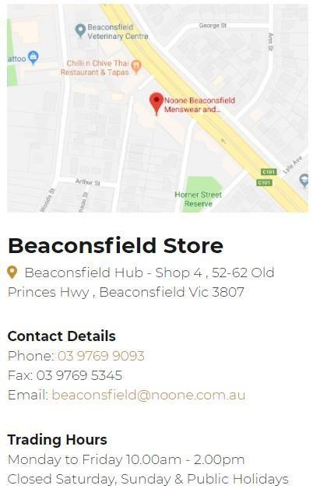
- College shirt (long sleeved or short sleeved)
- College summer dress
- Black pants
- Black shorts
- College black winter skirt
- College Jumper
- College knitted vest
- College puffer vest
- College softshell jacket
- Black socks or tights

Optional items:

- Head scarves (Hijabs) plain black
- College beanie
- College Cap/bucket hat
- College scarf
PE Uniform:
- College PE top – long sleeved or short sleeved
- College logo PE shorts
- College logo track pants
- College logo leggings
- College rugby jumper
- Plain black or white socks – no branding

Please note shoe requirements: Students at Clyde Secondary College are required to wear black leather shoes. Boots, ankle boots, slip on, zipped, canvas, suede, ballet style are not acceptable. For PE black or white runners must be worn.

General Appearance
Jewellery:
- Students may wear up to a maximum of two plain sleepers/studs per ear
- A religious chain (or symbol) or discreet necklace may be worn inside clothing
- A watch and/or one bracelet may be worn
Please note that all jewellery is to be worn respectfully and discreetly. It is at the discretion of the Principal (or his/her representative) that jewellery may be required to be removed for safety reasons.
Dress, shorts and skirt length must be appropriate for a school/professional environment.
School shorts and pants are not to be rolled up.
School pants should have length tailored appropriately, so as to maintain an even hem.
Socks should not be patterned or have visible branding.
Facial hair is permitted, provided it is well groomed
If hair is worn long, it may, for reasons of safety, be required to be tied back
Facial cosmetics may be worn discreetly and should not be noticeable (heavy mascara, bright eye shadows and lipstick are unacceptable)
Un-natural (or extreme) hair colours, hair styles and nails are not permitted Tattoos must be discrete or covered
Policy last reviewed | March 2024
Approved by | Principal
Next scheduled review date | March 2025

