YARD DUTY AND SUPERVISION POLICY

Help for non-English speakers
If you need help to understand the information in this policy, please contact
Clyde Secondary College, (03) 8560 0600.

PURPOSE
The purpose of this policy is to explain to staff at Clyde Secondary College yard duty procedures and expectations for the appropriate supervision of secondary students. Appropriate supervision is an important strategy to monitor student behaviour and enables staff to identify and respond to possible risks at school as they arise. It also plays a vital role in helping schools to discharge their duty of care to students.
OBJECTIVE
To ensure that school staff understand their supervision and yard duty responsibilities.
SCOPE
This policy applies to all teaching and non-teaching staff at Clyde Secondary College, including education support staff, casual relief teachers and visiting teachers.
POLICY
Appropriate supervision is an important strategy to monitor student behaviour and enables staff to identify and respond to possible risks at school as they arise. It also plays a vital role in helping schools to discharge their duty of care to students.
The principal is responsible for ensuring that there is a well organised and responsive system of supervision and yard duty in place during school hours, before and after school, and on school excursions and camps.
School staff are responsible for following reasonable and lawful instructions from the principal, including instructions to provide supervision to students at specific dates, time, and places. Supervision should be undertaken in a way that identifies and mitigates risks to child safety. Clyde Secondary College will inform parents/carers of the precise times during which the school grounds will be monitored via the College webpage and Compass.

Before and after school
Clyde Secondary College grounds are supervised by school staff from 8.30 am until 3.30 pm. Outside of these hours, school staff will not be available to supervise students. Students who may wish to attend school outside of these hours are encouraged to sign in and out of the front office and attend the library which is open from 8.30 am and closes at 4.15 pm.

Yard duty
All staff at Clyde Secondary College are expected to assist with yard duty supervision and will be included in the weekly roster.
The Daily Organiser is responsible for preparing and communicating the yard duty roster each term and daily as required to cover staff absence. At Clyde Secondary College, school staff will be designated a specific yard duty area to supervise.
Any students with positive behaviour plans or safety plans will have their plans available to all yard duty staff and communicated regularly at staff meetings. All outdoor areas are accessible to students with disability and additional needs, peer modelling and social integration between all students is encouraged.

Yard duty zones
The designated yard duty areas for our school as at Term 2, 2024 are:
Zone | Area
Green Zone | Basketball Court
Yellow Zone | Adjacent to multipurpose room and infront of admin
Dark Blue | Infront of LNA and STEM
Light Blue | Relocatables and grass area
Light Purple | Inside LNA and girls toilets
Pink | Inside STEM and boys toilet
Light Green | Canteen
Pale Yellow | Bus
Pale Green | Fernlea Homestead Road
Orange | Bike Shed
Light Pink | Library
Dark Pink | Woodfield
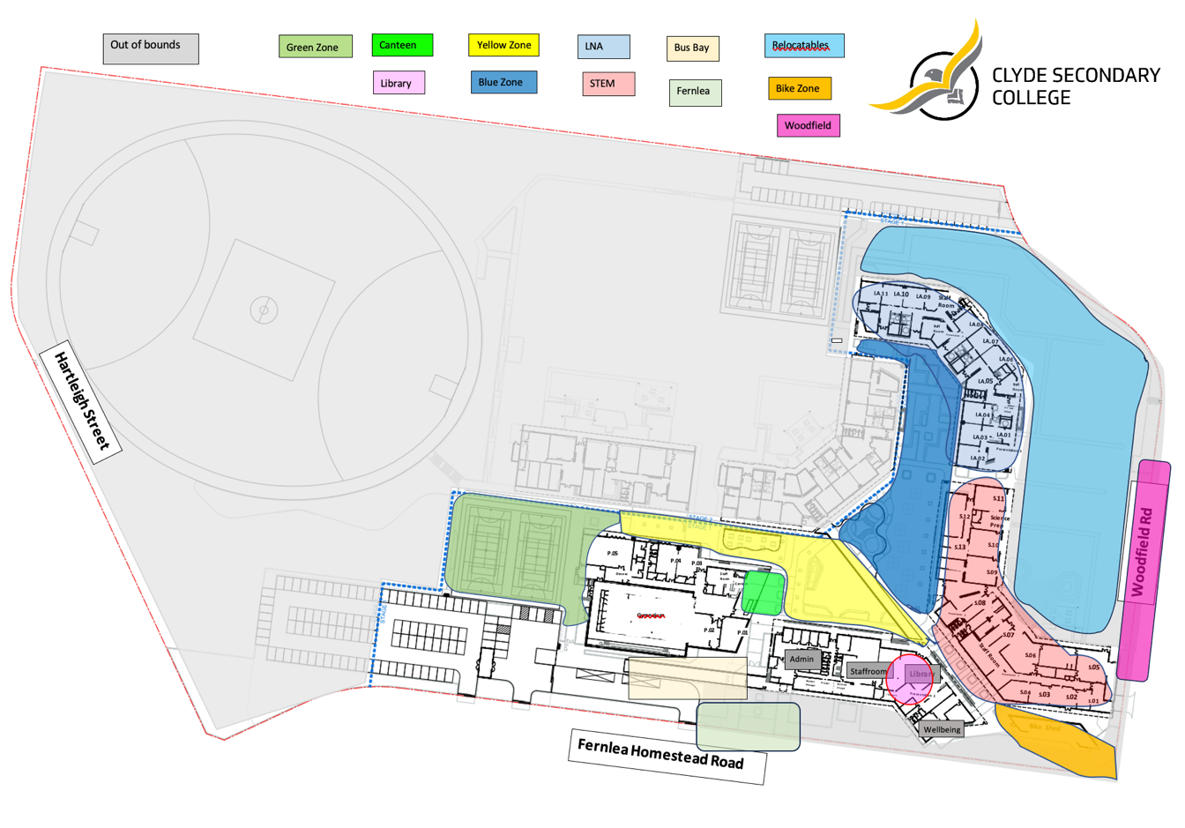
Each yard duty zone has yard duty supervisor. As the school grows the number of yard duty supervisors will increase.
Areas of the school under construction will be fenced off and actively patrolled by yard duty teachers. Workers on-site will be physically separated from students and where required to attend school grounds will be required to abide by the schools Visitors Policy. They will also be required to sign in, read and sign the Child Safe Code of Conduct in addition to having WWWC.
Yard duty equipment
School staff must:
- Wear a provided safety/hi-vis vest whilst on yard duty.
- Carry the yard duty first aid bag at all times during supervision
- Be familiar with the yard duty information pack containing student health and safety information
Yard duty equipment must be returned after the period of supervision or handed to the relieving staff member.
Yard duty responsibilities
Staff who are rostered for yard duty must remain in the designated area until they are replaced by a relieving teacher.
During yard duty, supervising school staff must:
- Wear high visibility vests provided to staff (stored in main staffroom)
- Collect first aid bumbag (4 x first aid bumbags are stored in the main staffroom)
- methodically move around the designated zone and actively supervise.
- Where safe to do so, approach any unknown visitor who is observed on school grounds without a clear legitimate purpose, and ensure they have a visitor pass and have signed in (excluding drop off and collection periods)
- be alert and vigilant
- recognise and acknowledge positive behaviour
- intervene immediately if potentially dangerous or inappropriate behaviour is observed in the yard
- enforce behavioural standards and implement appropriate consequences for breaches of safety rules, in accordance with any relevant disciplinary measures set out in the school’s Student Engagement policy
- ensure that students who require first aid assistance receive it as soon as practicable
- log any incidents or near misses on Compass
- return high visibility vest and first aid bumbag to main staff room
If being relieved of their yard duty shift by another staff member (for example, where the shift is ‘split’ into 2 consecutive time periods), the staff member must ensure that a brief but adequate verbal ‘handover’ is given to the relieving staff member in relation to any issues which may have arisen during the first shift. High visibility vests and first aid bumbag must also be handed over to the relieving staff member.
If the supervising teacher is unable to conduct yard duty at the designated time, they should contact the Daily Organiser with as much notice as possible prior to the relevant yard duty shift to ensure that alternative arrangements are made.
If the supervising teacher needs to leave yard duty during the allocated time, they should contact the Daily Organiser but should not leave the designated area until the relieving teacher has arrived in the designated area.
If a next duty teacher does not arrive for yard duty, the teacher currently on duty should contact the front office and not leave the designated area until a relieving teacher has arrived.
Students will be encouraged to speak to the supervising yard duty staff member if they require assistance during recess or lunchtime.

Classroom
The classroom teacher is responsible for the supervision of all students in their care during class.
If a teacher needs to leave the classroom unattended at any time during a lesson, he or she should first contact the front office for assistance. The teacher should then wait until a replacement staff member has arrived at the classroom before leaving. Educational Support Staff (ESS) who are aides in the classroom supporting students, cannot be left to supervise a class without a teacher present. The teacher may ask the ESS to get assistance as required.

School activities, camps, and excursions
The principal and leadership team are responsible for ensuring that students are appropriately supervised during all school activities, camps, and excursions, including when external providers are engaged to conduct part or all of the activity. Appropriate supervision will be planned for school activities, camps, and excursions on an individual basis, depending on the activities to be undertaken and the level of potential risk involved, and will follow the supervision requirements in the Department of Education Excursions Policy.

Digital devices and virtual classroom

Clyde Secondary College follows the Department’s Cybersafety and Responsible Use of Technologies Policy with respect to supervision of students using digital devices.
Clyde Secondary College will also ensure appropriate supervision of students participating in remote and flexible learning environments while on school site. In these cases, students will be supervised when undertaking virtual and remote learning while at school.
While parents are responsible for the appropriate supervision of students accessing virtual classrooms from home:
- student attendance will be monitored daily.
- any wellbeing or safety concerns for the student will be managed in accordance with our usual processes – refer to our Student Wellbeing and Engagement Policy and our Child Safety Responding and Reporting Policy and Procedures for further information.

Students requiring additional supervision support

As a SIS school, we recognise that some students will require additional supervision. In these cases, the Principal or delegate will ensure arrangements are made to roster additional staff as required. This may include on yard duty, in the classroom or during school activities. To further support students who are on the Program for Student with Disabilities (PSD) funded, we will roster integration aides for yard duty during recess and lunch as appropriate. In addition, there may be a need for the aides to be available to meet students at the beginning of the day, just before school or escort them to the bus or their parent/carers car. This will be factored into once based on needs of the individual students. This information will be gathered during student transition discussions in November/December each year.

Workplace learning programs

When students are participating in workplace learning programs, such as work experience, school-based apprenticeships and traineeships, and structured workplace learning, the safety and welfare of the student is paramount. Organising staff are required to follow all applicable Department of Education policies and guidelines in relation to off-site learning, including policy and guidelines on the safety and wellbeing of students. Refer to:
- Structure Workplace Learning
- School Based Apprenticeships and Traineeships
- Work Experience
- School Community Work

Independent Study

Year 12 students only will have one study block of three sessions per week. This will be timetables as a formal ‘study hall’ where teacher supervision and support will be provided, and attendance will be recorded by the supervising teacher. Students will not be permitted to leave school grounds during these sessions.
Depending on their program of study, VCE students will undertake independent study periods in Year 12 as part of their scheduled timetable. Students will be expected to use the college library for scheduled study periods, unless these fall at the beginning or end of the day, in which case students may arrive later or depart earlier in order to study from home. Once students are onsite, they are required to remain onsite until the end of their scheduled classes and are not permitted to sign in or out for reasons other than authorised absences, such as medical appointments.
Where a student in a lower year level has an independent study period – such as a student who is undertaking a study outside the college in their own time – they will be required to undertake that independent study in the college library.
Students will be required to sign in and out of the college library when entering for a study period.

Supervision of student in emergency operating environments

In emergency circumstances our school will follow our Emergency Management Plan, including with respect to supervision.
In the event of any mandatory period of remote or flexible learning our School will follow the operations guidance issued by the Department.

Other areas requiring supervision

Students working in the library will have supervision by an Educational Support Staff member, with access to a teacher in the near vicinity if further support is needed.

COMMUNICATION

This policy will be communicated to our school community in the following ways:

- Included in staff induction processes
- Discussed at staff briefings or meetings, as required
- Made available in hard copy from school administration upon request.

Information for parents and students on supervision before and after school is available on our school website and parent reminders are sent at the beginning of each term on Compass, Facebook and Instagram.

Further Information and Resources
This policy should be read in conjunction with the following Department polices and guidelines:
- Child Safe Standards
- Cybersafety and Responsible Use of Technologies
- Duty of Care
- Excursions
- Supervision of Students
- Visitors in Schools
- School Based Apprenticeships and Traineeships
- School Community Work
- Structured Workplace Learning
- Work Experience
POLICY REVIEW AND APPROVAL

Policy last reviewed | May 2024
Approved by | Principal
Next scheduled review date | May 2026

This policy will also be updated if significant changes are made to school grounds that require a revision of Clyde Secondary College yard duty and supervision arrangements.

